COMPLETED BY:
- Licensed/Waivered Psychologist
- Licensed/Registered/Waivered Social Worker or Marriage and Family Therapist
- Licensed/Registered Professional Clinical Counselor
- Physician (MD or DO)
- Nurse Practitioner

CO-SIGNATURE:
- Prior Authorization Day Service Requests must be completed by or co-signed by a Licensed Mental Health Professional
- Co-signature from Licensed Mental Health Professional indicates they have reviewed and agree with the findings of the request

COMPLETION REQUIREMENTS:
- Prior Authorization Day Services Request form is completed by the Day Services provider and
submitted to Optum via FAX (866) 220-4495 for all clients prior to the initial provision of Day
Services
- Continuing Prior Authorization Day Services Requests are completed by the Day Services provider and submitted prior to expiration of the initial authorization period (within 12 weeks for Intensive Outpatient Program [IOP] and 4 weeks for Partial Hospitalization Program [PHP])
- Continuing Prior Authorization Day Services Requests shall be submitted at least 5 business days prior to the expiration of Day Services Authorization, and can be submitted up to 10 business days prior to the expiration
- Prior authorization shall be obtained before Day Services are initiated. For hybrid programs, Outpatient
Services may be provided prior to the authorization of Day Services

DOCUMENTATION STANDARDS:
The following elements of the Prior Authorization Day Services Request form shall be addressed:

- Client Information
  - Include Name, Client ID and Date of Birth
- Day Program Information
  - Include Legal Entity, Program Name, Phone number, Fax number, Unit number, and Day Services
Program Subunit number
- Scope, Amount and Duration of Day Services Request
- Identify the scope and duration of Day Services to be provided (IOP – Day Intensive Half [DIH] for 8-12 weeks, PHP – Day Intensive Full [DIF] –2-4 weeks)
- Include the amount of services requested (select Up to 3 Days Per Week, Up to 5 Days Per Week or Up to 6 Days Per Week) which shall not exceed the Day Program schedule that has been approved by BHS QM

4. Medical Necessity Criteria for Day Services
- Diagnosis - Provide the ICD 10 mental health diagnoses that are the focus of mental health treatment
- Medical Necessity Criteria (BHIN 21-073)
- Select and explain the client’s condition that places them at high risk for a mental health disorder due to experiencing trauma
OR
- The client meets one of the following:
- Significant impairment or probability of significant deterioration in an important area of life function
- Reasonable probability of not progressing developmentally as appropriate
- Need for specialty mental health services, regardless of presence of impairment, that are not included within the mental health benefits that a Medi-Cal managed care plan is required to provide
AND
- The client’s condition is due to one of the following:
- A diagnosed mental health disorder
- A suspected mental health disorder not yet diagnosed
- A significant trauma putting the client at risk for a future mental health diagnosis

5. Ancillary Services Request (Internal)
- IOP must complete the Ancillary Request section in order to provide Day Services and Outpatient Specialty Mental Health Services (SMHS) during the course of treatment
- IOP shall only provide Outpatient SMHS outside of scheduled Day Service hours, or during scheduled Day Service hours if the youth is unable to attend the Day Program that day
The following Outpatient SMHS is never allowed to be claimed on the same day that Day Services have been claimed:
- Targeted Case Management
Additionally, the following SMHS are never allowed to be claimed as Outpatient Services at any time while a client is enrolled in Day Services, as they are bundled with Day Services
- Assessment LPHA
- Assessment Contribution
- Provide the Day Program Outpatient number
- Select the amount of Outpatient SMHS requested per day (up to 8 hours)

- Select and describe at least one reason Outpatient SMHS are medically necessary in addition to Day Services
- Reason why; requested service(s) is not available during day program hours
- Reason why; continuity or transition issues make these services necessary for a limited time
- Reason why; these concurrent services are essential for coordination of care
- Note; if the client is receiving ancillary SMHS from another program or provider, the Day Services Provider shall coordinate with the separate Outpatient Provider to complete a stand-alone Ancillary SMHS Request Form
7. Signature(s)
- Must include the printed/typed name, credentials, signature and date of the Program Clinician completing the request
- Must include the printed/typed name, credentials, signature and date of a Licensed Mental Health Professional if the Program Clinician completing the request is not a Licensed Mental Health Professional

OPTUM AUTHORIZATION SECTION
- The following sections are completed by Optum upon receipt from the Day Services provider
- Optum will review and retain the Prior Authorization Day Services Request (DSR) form
- Within 5 business days of Optum receiving the DSR, authorization(s) will be viewable in the SmartCare Authorization Report- Expiry, Exhaustion and Utilization % (My Office)

- Day Services Prior Authorization Determination
- When the scope, amount and duration of services are authorized, the start date and end date shall be viewable to the requesting provider in the Authorization Report- Expiry, Exhaustion and Utilization % (My Office).. Day Services authorizations will be indicated by the applicable selected authorization code.
- When the Prior Authorization Day Service Request is denied, modified, reduced, terminated, or suspended a NOABD shall be issued by Optum to the Medi-Cal beneficiary and requesting provider

- Ancillary Services Determination (Internal)
- When the Internal Ancillary Outpatient Services are authorized, the start date and end date shall be viewable to the requesting provider in the Authorization Report- Expiry, Exhaustion and Utilization % (My Office). Internal Ancillary Services will be indicated by the applicable selected authorization code.
- When the Prior Authorization Day Service Request is denied, modified, reduced, terminated, or suspended a NOABD shall be issued by Optum to the Medi-Cal beneficiary and requesting Day Service provider

- Ancillary Services Determination (External)
- When an ancillary Specialty Mental Health Provider (SMHP) begins treatment, a stand-alone “Ancillary SMHS Request” form must be submitted to Optum by the Day Service provider to request ancillary SMHS from a separate program/provider in addition to Day Services
- When external ancillary services are authorized, the start date and end date shall be viewable to the requesting provider and the ancillary SMHP in the Authorization Report- Expiry, Exhaustion and Utilization % (My Office). External ancillary services will be indicated by the applicable selected authorization code.
- When the External Ancillary Services Request is denied, modified, reduced, terminated, or suspended a NOABD shall be issued by Optum to the Medi-Cal beneficiary and the requesting Day Service Provider, who shall communicate with the ancillary SMHP within 3 business days
- See “Ancillary SMHS Request” form and explanation form for additional information

Authorization Report- Expiry, Exhaustion and Utilization % (My Office) in SmartCare Export Instructions:
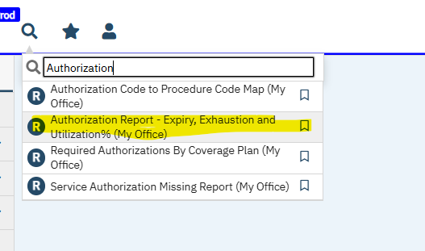
- Search in SmartCare search field and type in Authorization and select Authorization Report – Expiry, Exhaustion and Utilization% (My Office)

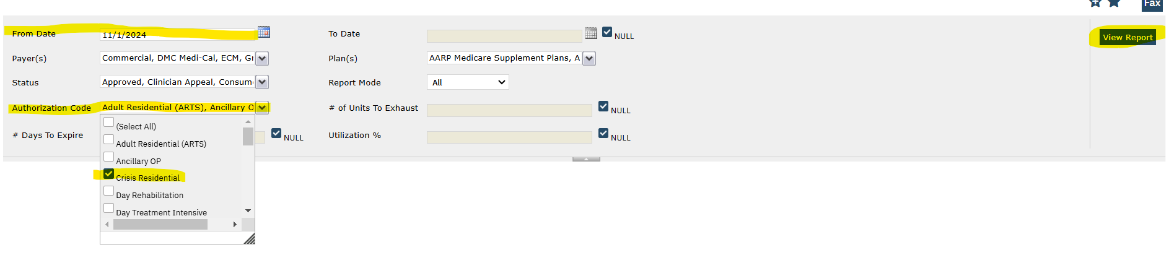
2
4
3
3
- Select your ‘From Date’ which will be the date your review period begins.
- Select your type of program from the ‘Authorization Code’ drop down.
- Select View Report
- Export to Excel
5
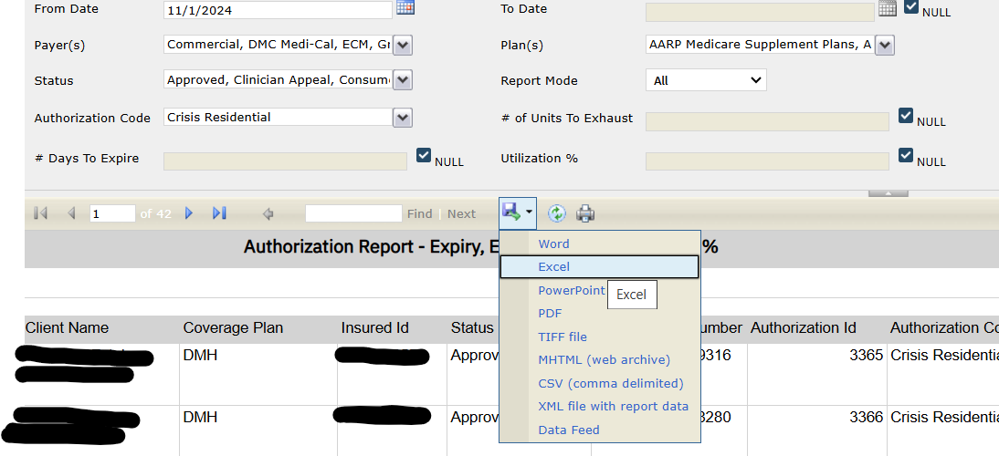

Note: The Prior Authorization Day Services Request (DSR) form replaces the Intensive Services Request (ISR) form effective 1/1/2020
References:
Behavioral Health Information Notice (BHIN) No: 21-073 Dated 12/12/2021 : Criteria-for-Beneficiary-to-Specialty-MHS-Medical-Necessity-and-Other-Coverage-Req
DHCS MHSUDS INFORMATION NOTICE NO.: 19-026 Dated 5/31/19: Authorization of Specialty Mental Health Services
DMH INFORMATION NOTICE NO.: 02-06 Dated 10/1/02: Changes in Medi-Cal Requirements for Day Treatment Intensive and Day Rehabilitation

